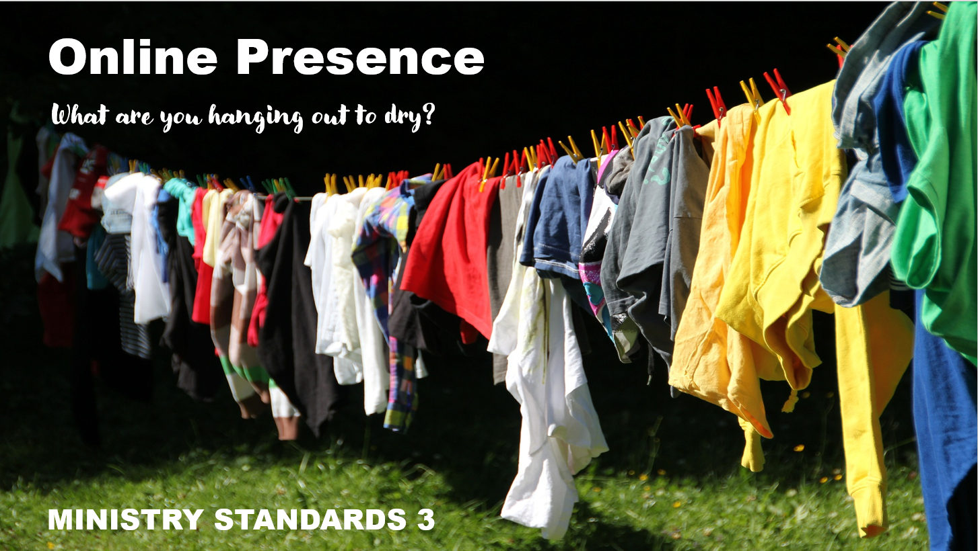
The following material has been adapted from Rev Sarah Park’s Ministry Standards Training.

Exploring the Boundaries: Availability
- Does your role come with defined working hours? Are you available any time?

- How does social media change your perceived or real availability?

- How does giving your private phone number or cellphone number change your perceived or real availability?

- What is the email address you give out for people to contact you? Is it shared or private?

- Do you have a policy about whether ‘clients’ can be your Facebook friends? What is the implication of this?

Facebook, texts and emails mean that it is possible to be available 24/7. It is important to place boundaries around our availability so that we can do justice to the primary relationships in our lives, as well as the need for rest and recreation. While there are certainly situations which demand our urgent and immediate attention, there is also a need for us to take charge of our own availability.

Strategies for managing your availability

Facebook

Email/Messaging

Phone

Day off

Social invitations

Exploring the Boundaries: Initiating Contact
- When initiating contact with a ‘client’ outside your usual setting, what might you need to think about?

- If the relationship is one of unequal power, who else might need to be party to the communication?

- What accountability/safety measures might you put in place?

Exploring the Boundaries: Self Disclosure
The pastoral relationship is intimate … but this does not mean that the intimacy is mutual, nor does it mean that the experience has the same meaning for both parties.

- What is appropriate to reveal about yourself, your personal life and circumstances?

- Is it possible to have an authentic pastoral relationship without any self-disclosure?

Discussing our own problems with those for whom we have pastoral responsibility can indicate that a boundary is under threat. The risk is that the care giver/minister starts to become cared for/ministered to, by sharing inappropriate personal information/needs.

Social/Pastoral Implications in an online world
Among the most frequently treated internet-related problems by mental health professionals:

- Overuse
- Pornography
- Infidelity
- Risky behaviours

Internet usage poses the risk of addiction and compulsivity.
- Accessibility and Affordability
Which includes access to:
- Sexually oriented materials and activities
- Gambling
- Gaming
All of these are psychologically reinforcing and potentially highly addictive
- Anonymity (assumed)
- When anonymity is assumed people are far more likely to say and do things that they wouldn’t do in ‘real’ time.

“Online sexual compulsivity is very difficult to self-treat… Further, some psychologists suggest that successful treatment and recovery cannot be achieved simply by value-based arguments or ethical persuasion. That’s because in most cases, the person engaging in online sexual compulsivity has already experienced a disconnect between values and behaviour.”

Timo, Millspaugh and Stuart, from the ‘Our Whole Lives’ curriculum

Charting my Internet Use
How many hours each week do you spend using the internet for:
Ministry?

Study and research?

Spiritual nurture?

Recreation and entertainment?

Socialising?

Managing personal affairs (eg banking)

How does this affect your personal and professional life?
Yes No Are you neglecting areas of ministry because of your time online?

Yes No Are you neglecting personal and family relationships? Would members of your family say you spend too much time online?

Yes No Are you engaging in risky online behaviour (sexting, “anonymous” chat rooms or sexual interaction)?

Strategies for putting boundaries around internet usage:
- Regularly assess your usage of the internet.
- Limit time on the computer for both work and play.
- Try an internet Sabbath each week.
- Turn off the computer when not using it.
- Develop and maintain embodied relationships with family, friends, parishioners.
- Practice other wellness activities such as exercise, spiritual nourishment, and other off-line creative pursuits.

General issues to consider
- Internet permanency
- Privacy and confidentiality
- Private versus professional
- Delineating responsibility
- Preventing abuse and online bullying

Blogs and Websites

Advantages
- Good “advertising”
- Sharing the good news
- Platform for ideas
- Public and transparent

Disadvantages
- Easy to use as a notice board and therefore becomes dated
- How to respond to comments that are inappropriate

Twitter
- Instant communication
- Public communication
- Tool for mobilising of social justice response
- For what purpose?
- Limited space = limited communication (open to misinterpretation)
- Permanency
- Can be invasive

Email

Advantages
- Enhances communication with parishioners and colleagues because it is instant and broadcast
- Saves time and effort
- Avoids phone tag
- Allows some clients to talk about things they would find hard to discuss face to face.

Disadvantages
- It can avoid personal interaction.
- Generation Gap: not everyone has email access
- Can create an expectation of instant response. Emails often sent late at night or early in the morning
- Written communication can be misinterpreted creating unnecessary problems
- Email is not the appropriate vehicle for every communication.

Pastoral Pause
When communicating something complex or responding to an email that has angered you, it is important not to respond too quickly. The pastoral pause offers an opportunity to assess your response once you have taken time over it.
- Delete the person’s email address out of the TO: line while you write and edit a response. It is too easy to mistakenly hit send on an email you may later regret.
- When considering copying someone in, ask yourself whether it is necessary.
- Always expect that your email will be copied to an audience for whom it was not intended.
- Write a draft and then walk away. Would you say this face to face?
- If appropriate, check with someone else that what you have written is clear, and the tone is professional.

Social Media

Advantages
- Easy to keep members informed
- Ability to connect
- Can organise groups for specific purposes

Disadvantages
- Easy to violate boundaries – relationships can be invisible.
- Permanency
- Necessity to distinguish between role and private life

Some things to think about
- Have a policy on social media and internet usage. (See separate handout on forming a social media policy)
- Include transparency in your policy.
- Have someone in your organisation supervising/monitoring the content of social media sites.
- Direct clergy not to ‘friend’ members, but only respond to requests
- Separate personal and professional accounts on social media?
- Policy for youth workers.
- Who may initiate contact on social media and how?
- How are adult-minor relationships public and transparent?
- How are photos and video shared?

